**ASSIGNMENT 7**

**1. Get count of employees having last name same as first name of other**

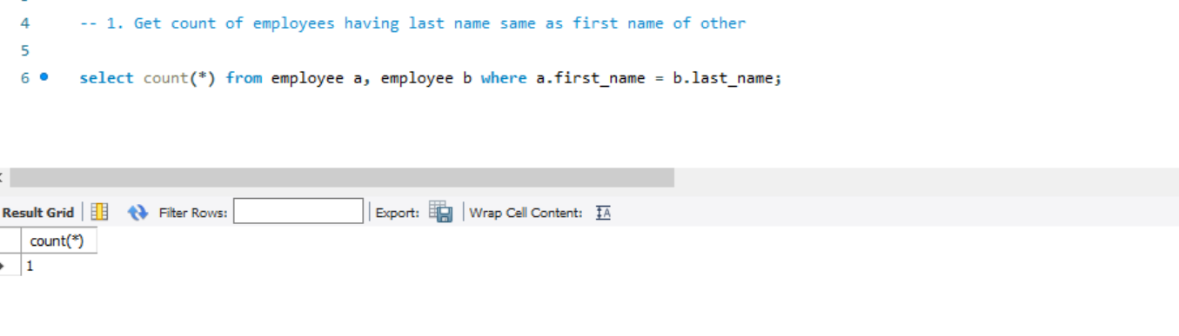2**. List employees having last name same as first name of other**

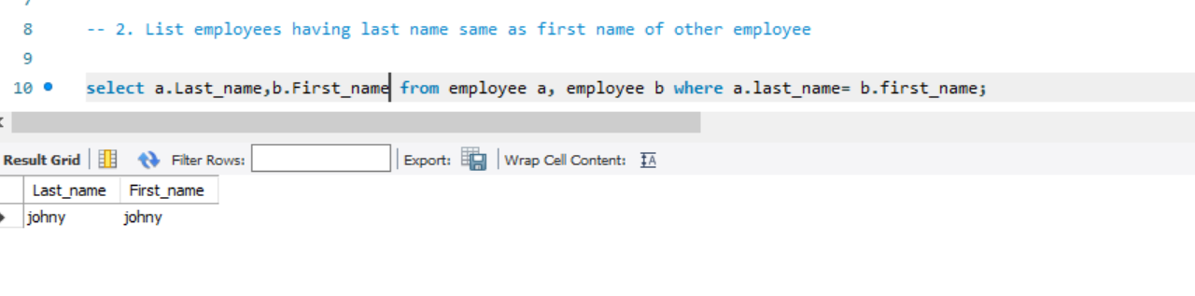

**3. List FName,LName,rewardamount of employees having last name same as first name of other employees or vice-versa, with each of their reward amount**

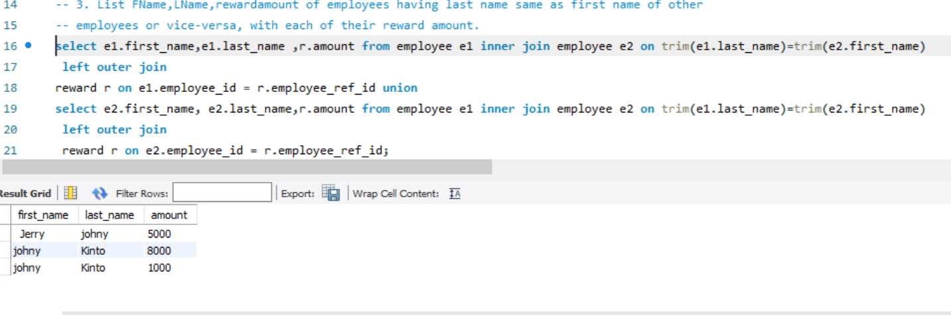

**4. Display the tours with source and destination as follows (use: places, tours tables**

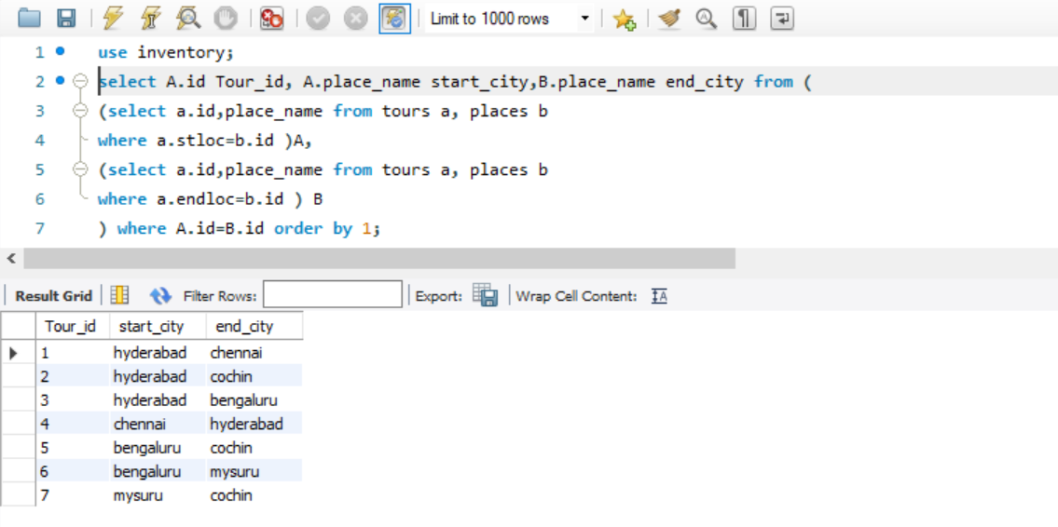

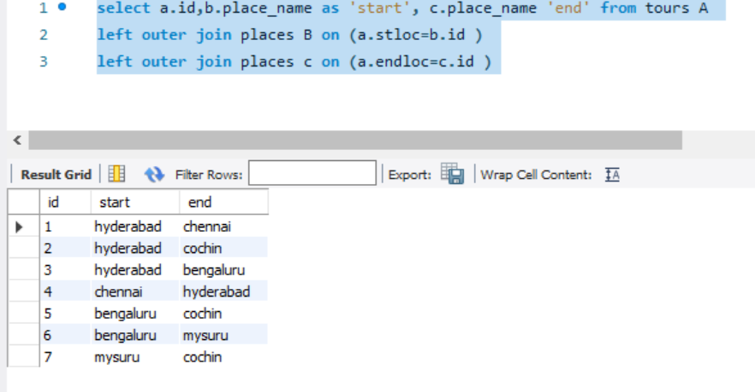

**5. Find duplicate outlet type with each its predecessor and successor**

